
The University of Azad Jammu & Kashmir
Name | Rizwan Ali
Roll No | 2025-SET-40
Lab No | 01
Instructor | Sir Fahad Nisar
Course | Software Configuration and Management Technologies

1.Verification of git Installation

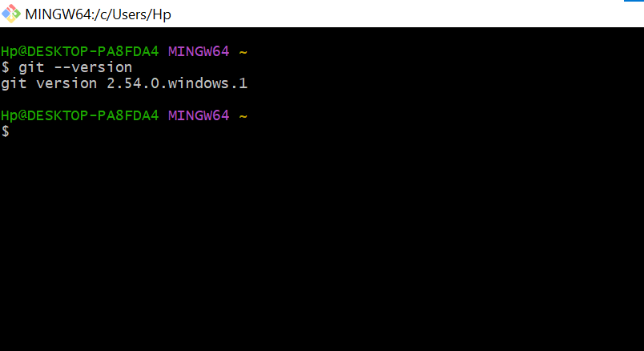
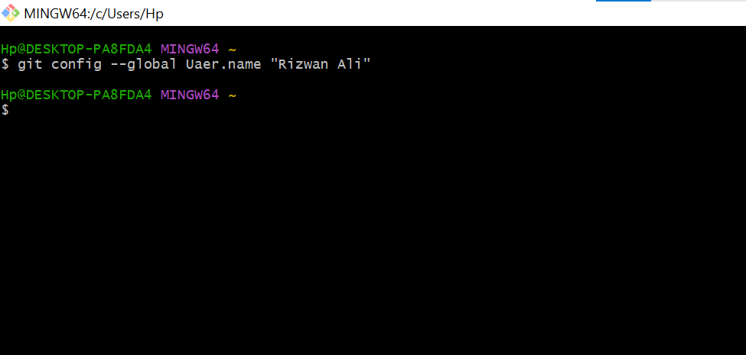
2.Global Username configuration

3. Global Email configuration
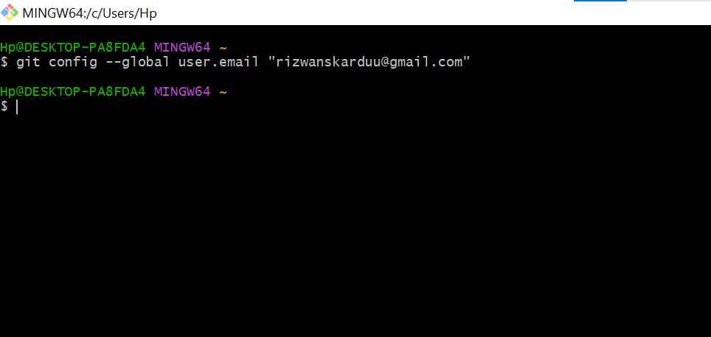
4. Default Text Editor Configuration

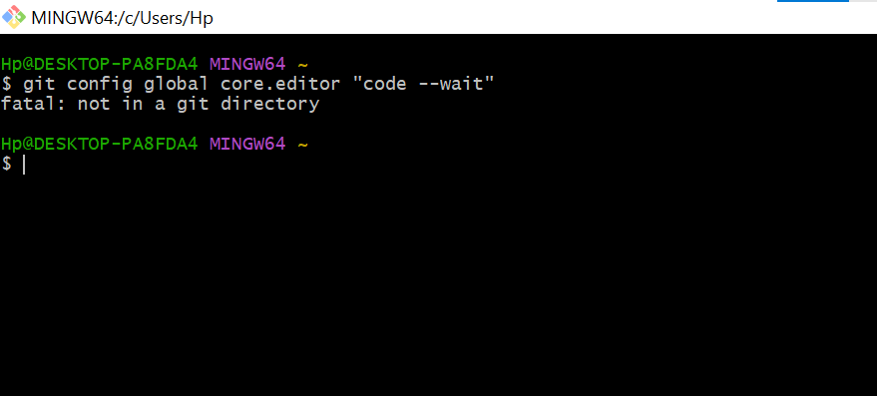

5. Verification of git Configuration List

